
RIGA TECHNICAL UNIVERSITY
Faculty of Computer Science and Information Technology Institute of Applied Computer Systems

“Data Structure Individual Assignment”
TASK OF INDIVIDUAL WORK
"DIP203 - Data Structures”

Asst: Prof, Padmaraj Nidagundi

Accomplished: Ngoc Bao Tram Tran
Student Card No: 231ADB294

2025./2026.
INDEX

Basic Data Structure 4
a) Write a program to display the "Hello world!" string to the console. 4
b) Write a program to add two numbers and display results. 4
Data structure 5
Linear Data Structures (Non-Primitive) 7
1. Array 7
a) Explain the concept of an array. Provide an example to illustrate how arrays are used in programming. 7
b) Write a program for array implementation. 8
2. Linked List 10
a) Define a linked list and describe its basic components. Discuss the differences between singly linked lists and doubly linked lists. 10
b) Write a program for linked list implementation. 11
3. Stack 13
a) Explain the principles of a stack. Describe how a stack can be implemented using an array. 13
b) Write a program for stack implementation. 14
4. Queque 16
a) Discuss the concept of a queue. Differentiate between a circular queue and a priority queue. 16
b) Write a program for queue implementation. 16
Non-Linear Data Structures (Non-Primitive) 19
1. Trees 19
a) Explain the hierarchical structure of trees. Differentiate between a binary tree and a binary search tree. 19
b) Write a program for binary tree implementation. 20
2. Graphs 24
a) Define a graph and discuss its various representations (adjacency matrix, adjacency list). 24
b) Write a program for graph implementation. 25
3. Hash Table 26
a) Describe the concept of a hash table. Discuss collision resolution techniques. 26
b) Write a program for hash table implementation. 27
Overall 29
a) What is the difference between Non-Primitive (Linear data structure) and Non-Primitive (Non-linear data structure) 29
b) What is the difference between a Primitive and Non-Primitive data structure? 30
c) Why we need to learn data structure (make a 2-page short report) 30
d) What are Big-O complexities and why are they used in Computer Science (programming)? 32
e) How do you select an appropriate data structure in your program? 34
Bibliography 36

ASSIGNMENT

Basic Data Structure
1.
- Write a program to display the "Hello world!" string to the console.
Program:
/*Method 1*/  #include <iostream>  int main()  {  std::cout << "Hello World";  return 0;  } | /*Method 2*/  #include <iostream>  using namespace std;  int main()  {  cout << "Hello World";  return 0;  }
Output:
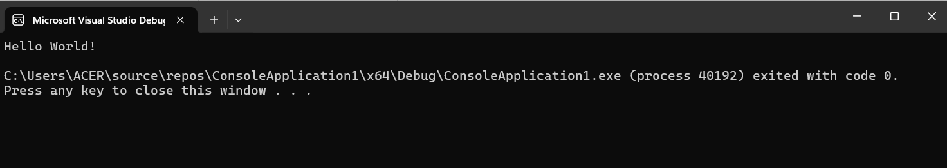

Write a program to add two numbers and display results.
Program:
/*Method 1*/  #include <iostream>  int main() {  double num1, num2;  std::cout << "Enter the first number: ";  std::cin >> num1;  std::cout << "Enter the second number: ";  std::cin >> num2;  double sum = num1 + num2;  std::cout << "The sum of " << num1 << " and " << num2 << " is: " << num1 << " + " << num2 << " = " << sum << std::endl;  return 0;  } | /*Method 2*/  #include <iostream>  using namespace std;  int main() {  double num1, num2;  cout << "Enter the first number: ";  cin >> num1;  cout << "Enter the second number: ";  cin >> num2;  double sum = num1 + num2;  cout << "The sum of " << num1 << " and " << num2 << " is: " << num1 << " + " << num2 << " = " << sum << endl;  return 0;  }
Output:
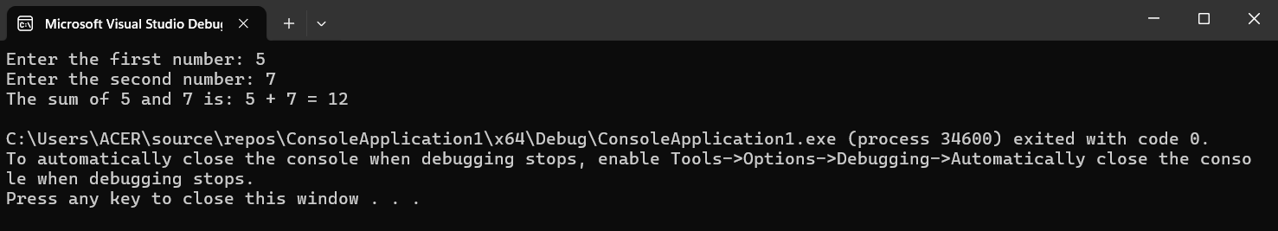
2. Make a 4-page short report about different data structures.

Data structure
A data structure is a specific method for arranging data in a computer, allowing it to be accessed and used efficiently. The goal is to optimize space usage and minimize the time required for various operations. [1]
Sorting
Sorting involves reorganizing an array or list of elements based on a comparison operator. This comparison operator determines the new order of the elements within the data structure.
In data structures, various sorting algorithms are employed, which can be broadly categorized into two types:
- Comparison-based: These algorithms sort elements by comparing them against each other. For instance: Bubble Sort, Insertion Sort, Selection Sort, Quick Sort, Merge Sort, and Heap Sort.
- Non-comparison-based: These algorithms sort elements without comparing them directly. For instance: Counting Sort, Radix Sort.
Binary Tree
A Binary Tree Data Structure is a hierarchical structure where each node has up to two children, known as the left child and the right child. It is widely used in computer science for the efficient storage and retrieval of data, supporting various operations like insertion, deletion, and traversal.
Traveling Salesman
The traveling salesman problem is a well-known issue in mathematics, operations research, and optimization. It involves determining the order in which a traveling salesman should visit several cities to minimize the total travel distance, ensuring each city is visited once before returning to the starting point. Sub-tours, where the route is divided into multiple trips, are generally not permitted.
This problem's significance lies in its relevance to various real-world scenarios. For instance, a package delivery company may need to find the shortest route to deliver packages efficiently, saving time and fuel. In circuit board manufacturing, optimizing the order of drilling holes can greatly enhance process efficiency. Despite the different specifics, these scenarios are all variations of the traveling salesman problem.
However, solving the traveling salesman problem is challenging. Exact solutions that yield the optimal path are feasible for a small number of cities, but as the number of cities increases, the computation time grows exponentially. Integer programming with branch and bound is one approach to finding exact solutions. For larger numbers of cities, heuristic algorithms that approximate the optimal solution are typically used, sacrificing a bit of accuracy for a significant reduction in computation time. A notable example of an approximate solution is the Christofides algorithm, which ensures a path no more than 1.5 times the length of the optimal path.
In summary, the traveling salesman problem seeks the shortest path to visit a set of locations. Solutions can be exact, which do not scale well, or approximate, which are faster but may produce slightly longer paths.

Data structures are fundamental components in computing. They play a crucial role in efficiently managing, processing, accessing, and storing data. Each type of data structure has its own characteristics, features, applications, advantages, and disadvantages, making it important to select the right one for a specific task. The choice of an appropriate data structure depends on the specific requirements of the task at hand, including the type of data, the operations needed, and performance considerations.
- Array: Used for storing elements of the same type in a contiguous block of memory. They allow fast access to elements by index but have a fixed size.
- Linked Lists: Consist of nodes where each node contains data and a reference to the next node. They allow dynamic memory allocation and efficient insertions and deletions but have slower access times compared to arrays.
- Stacks: Follow the Last In, First Out (LIFO) principle. They are used in scenarios such as function call management and expression evaluation.
- Queues: Follow the First In, First Out (FIFO) principle. They are used in scenarios like task scheduling and handling asynchronous data.
- Trees: Hierarchical structures with nodes connected by edges. Common types include binary trees, binary search trees, and AVL trees. They are used in applications like database indexing and hierarchical data representation.
- Graphs: Consist of vertices connected by edges. They are used to model networks, such as social networks, transportation systems, and communication networks.
- Hash Tables: Store key-value pairs and provide efficient data retrieval using hash functions. They are commonly used in implementing associative arrays and databases.
Data in a data structure can undergo specific operations, and the choice of data structure often depends on how frequently those operations need to be executed. There are basic operations including traversing, searching, insertion, deletion, selection, sorting, splitting, merging and updating.
- Tranverse: Traversing a data structure involves systematically accessing every element within it. This operation is essential for performing tasks such as displaying elements or applying operations to them. Traversal can be applied to any type of data structure and ensures that each element is visited at least once.
- Search: Searching refers to the process of finding a specific element within a data structure. We can search an element using the given index or by the value. The search is deemed successful when the target element is identified. This operation can be carried out on various data structures, including arrays, linked lists, trees, and graphs.
- Insert: Insertion is a fundamental operation performed across all data structures, involving the addition of an element into the specified structure. The operation is considered successful when the element is appropriately added. However, insertion can fail if the data structure has reached its capacity and cannot accommodate any more elements. This operation goes by the general term "insertion" in data structures such as arrays, linked lists, graphs, and trees. In stacks, this action is specifically referred to as "push," and in queues, it is known as "enqueue."
- Deletion: It is an operation that we use on all data structures. Deletion means removing an element from the given structure. The deletion is considered successful when the specified element is removed. This operation is referred to as deletion in data structures like arrays, linked lists, graphs, trees, etc. However, in a stack, this operation is known as Pop, and in a queue, it is called Dequeue.
- Selection: Selection involves choosing specific data from the present dataset. You can select particular data by applying a condition within a loop.
- Sort: Sorting is the process of rearranging the elements of a given array or list of elements according to a comparison operator on the elements. This reordering can arrange elements in either ascending or descending order. To sort data efficiently (in less time), various sorting algorithms can be employed. For instance, bubble sort, which has a time complexity of O(n^2) to sort data. Other common sorting algorithms include merge sort, insertion sort, selection sort, quick sort, etc.
- Split: Segmenting data into various sections to reduce the overall processing time.
- Merge: To merge data from two different orders in a specific order, either ascending or descending. This operation is often used in conjunction with the split operation in sorting algorithms like merge sort.
- Update: Updating refers to modifying an existing element in a data structure. This operation can involve changing the value of an element or changing its position based on certain criteria. Can also update specific data by applying a condition within a loop, similar to a selection approach.

Linear Data Structures (Non-Primitive)

1. Array

a) Explain the concept of an array. Provide an example to illustrate how arrays are used in programming.
An array is a linear data structure that is a collection of items stored at consecutive memory locations. The concept is to keep multiple items of the same type together in one place, facilitating the processing of large amounts of data in a relatively short time. The first element of the array is accessed with an index of 0. Various operations can be performed on an array, such as searching, sorting, inserting, traversing, reversing, and deleting. An array has a fixed size, which means that once its size is set, it cannot be altered. Arrays can handle complex data structures by storing data in two-dimensional arrays, three-dimensional arrays.
Example: Calculating the Average of Student Scores
#include <iostream>
using namespace std;

int main() {
// Step 1: Define an array to store student scores
const int numStudents = 10;
int student_scores[numStudents] = {85, 92, 78, 90, 88, 79, 84, 91, 76, 95};

// Step 2: Calculate the total sum of scores
int total_sum = 0;
for (int i = 0; i < numStudents; ++i) {
total_sum += student_scores[i];
}

// Step 3: Calculate the number of students – This case is 10

// Step 4: Calculate the average score
double average_score = static_cast<double>(total_sum) / numStudents;

// Step 5: Print the average score
cout << "The average score of the students is: " << average_score << endl;

return 0;
}

- Define an Array: We create an array student_scores with a constant size numStudents to hold the scores of the students.
- Calculate the Total Sum: We use a for loop to iterate through the array and calculate the total sum of all scores.
- Calculate the Number of Students: The number of students is defined by the constant numStudents.
- Calculate the Average Score: We calculate the average score by dividing the total sum by the number of students, using static_cast<double> to ensure the division is performed as floating-point division.
- Print the Average Score: We print the average score using cout.

b) Write a program for array implementation.
Program:
#include <iostream>
#include <string>

class Array {
private:
std::string* arr;
int capacity;
int size;

public:
// Constructor to initialize array
Array(int capacity) {
this->capacity = capacity;
this->size = 0;
arr = new std::string[capacity];
}

// Destructor to clean up memory
~Array() {
delete[] arr;
}

// Function to add element at the end
void insert(const std::string& element) {
if (size < capacity) {
arr[size] = element;
size++;
} else {
std::cout << "Array is full. Cannot insert element." << std::endl;
}
}

// Function to get element at index
std::string get(int index) const {
if (index >= 0 && index < size) {
return arr[index];
} else {
std::cout << "Index out of bounds." << std::endl;
return "Error"; // Returning "Error" to indicate out of bounds
}
}

// Function to update element at index
void update(int index, const std::string& element) {
if (index >= 0 && index < size) {
arr[index] = element;
} else {
std::cout << "Index out of bounds. Cannot update element." << std::endl;
}
}

// Function to display the array
void display() const {
std::cout << "Array elements: ";
for (int i = 0; i < size; i++) {
std::cout << arr[i] << " ";
}
std::cout << std::endl;
}

// Function to get the current size of the array
int getSize() const {
return size;
}
};

int main() {
Array arr(10);

arr.insert("Pizza");
arr.insert("Burger");
arr.insert("Pasta");
arr.display(); // Output: Array elements: Pizza Burger Pasta

std::cout << "Element at index 1: " << arr.get(1) << std::endl; // Output: Element at index 1: Burger

arr.update(1, "Sushi");
arr.display(); // Output: Array elements: Pizza Sushi Pasta

std::cout << "Element at invalid index 10: " << arr.get(10) << std::endl; // Output: Index out of bounds. Element at invalid index 10: Error

std::cout << "Current size of the array: " << arr.getSize() << std::endl; // Output: Current size of the array: 3

return 0;
}
Output:
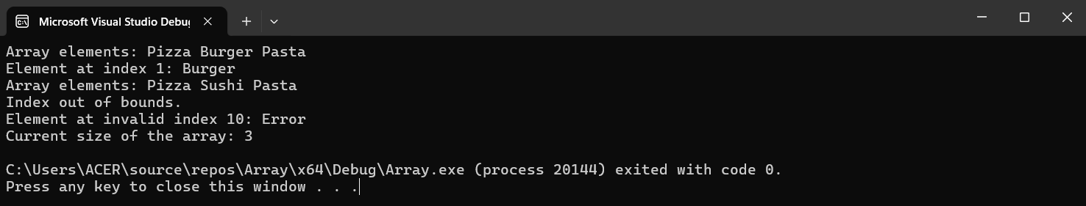

2. Linked List

a) Define a linked list and describe its basic components. Discuss the differences between singly linked lists and doubly linked lists.
A linked list is a linear data structure where elements are not stored in contiguous memory locations but are linked using pointers. There are various types of linked lists, including singly linked lists, doubly linked lists, circular linked lists, and doubly circular linked lists. Linked lists have several characteristics: they use extra memory to store links, do not require the size of elements to be known during initialization, and are used to implement stacks, queues, graphs, and other structures. Linked lists allow easy insertion and deletion of elements.
The first node of the linked list is called the Head, and the next pointer of the last node always points to NULL. Each node in a linked list contains a pointer that holds the address of the next node. They can dynamically grow or shrink at any time, making them highly flexible.

Singly Linked List (SLL) | Doubly Linked List (DLL)
Nodes in a SLL contain two fields: a data field and a next link field. | Nodes in a DLL have three fields: a data field, a previous link field, and a next link field.
In a SLL, traversal can be done using only the next node link, making it possible to traverse in only one direction. | In a DLL, traversal can be performed using either the previous node link or the next node link. This allows for traversal in both directions: forward and backward.
A SLL occupies (also consumes) less memory than a DLL because it has only two fields. | A DLL occupies (also consumes) more memory than a SLL because it contains three fields.
The complexity of insertion and deletion at a specific position is O(n). | The complexity of insertion and deletion at a given position is O(n / 2) = O(n) since traversal can be performed from either the start or the end.
The time complexity for deletion given a specific node is O(n) because it requires knowing the previous node, which necessitates traversing the list, taking O(n) time. | The time complexity for deletion given a specific node is O(1) because the previous node can be accessed easily.
Generally prefer to use a SLL for implementing stacks. | A DLL can be used to implement heaps, stacks, and binary trees.
When there's no need for search operations and memory saving is a priority, we opt for a SLL. | For more efficient searching, using a DLL list is a better choice.
A SLL is less efficient. It is preferred when memory saving is important and searching is unnecessary, as only a single pointer per node is stored. | A DLL is more efficient. It is used when memory is not a concern and better performance during searching is needed.

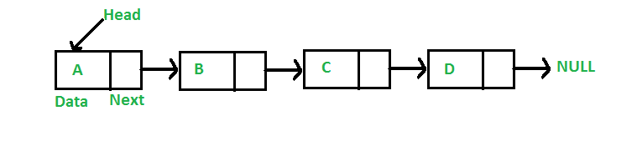
Image of Singly Linked List (SLL):

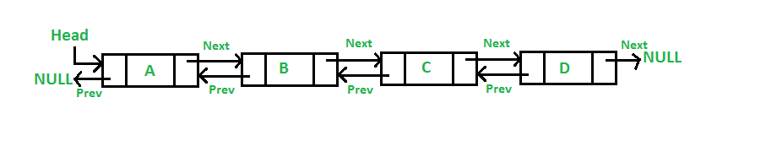
Image of Doubly Linked List (DLL):

- Write a program for linked list implementation.
Program:
#include <iostream>
#include <string>
using namespace std;

// Node class representing each node in the linked list
class Node {
public:
string drinkName; // Name of the drink
Node* next; // Pointer to the next node in the list

// Constructor to initialize a new node
Node(string drinkName) {
this->drinkName = drinkName;
this->next = nullptr;
}
};

// LinkedList class to manage the linked list operations
class LinkedList {
private:
Node* head; // Pointer to the head node of the list

public:
// Constructor to initialize an empty linked list
LinkedList() {
head = nullptr;
}

// Function to insert a new node at the end of the list
void append(string drinkName) {
Node* newNode = new Node(drinkName);

// If the list is empty, set the new node as the head
if (head == nullptr) {
head = newNode;
return;
}

// Otherwise, traverse to the end of the list and add the new node
Node* temp = head;
while (temp->next != nullptr) {
temp = temp->next;
}
temp->next = newNode;
}

// Function to display the list elements
void display() {
Node* temp = head;
while (temp != nullptr) {
cout << temp->drinkName << " -> ";
temp = temp->next;
}
cout << "nullptr" << endl;
}

// Function to delete a node with the given drink name
void deleteNode(string drinkName) {
// Store head node
Node* temp = head;
Node* prev = nullptr;

// If head node itself holds the drink name to be deleted
if (temp != nullptr && temp->drinkName == drinkName) {
head = temp->next; // Changed head
delete temp; // Free old head
return;
}

// Search for the drink name to be deleted, keep track of the previous node as we need to change 'prev->next'
while (temp != nullptr && temp->drinkName != drinkName) {
prev = temp;
temp = temp->next;
}

// If drink name was not present in linked list
if (temp == nullptr) return;

// Unlink the node from linked list
prev->next = temp->next;

delete temp; // Free memory
}
};

int main() {
LinkedList drinksList;

drinksList.append("Coke");
drinksList.append("Pepsi");
drinksList.append("Sprite");
drinksList.append("Fanta");

cout << "Drinks List: ";
drinksList.display();

cout << "Deleting drink: Pepsi" << endl;
drinksList.deleteNode("Pepsi");

cout << "Drinks List after deletion: ";
drinksList.display();

return 0;
}
Output:
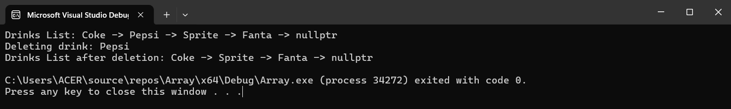

3. Stack

a) Explain the principles of a stack. Describe how a stack can be implemented using an array.
A stack is a linear data structure that operates on a Last In First Out (LIFO) principle, where operations are performed in a specific order. Data can be entered (pushed) and retrieved (popped) only from one end, known as the top of the stack. A key characteristic of stacks is that the first element inserted is the last to be removed and vice versa.
A stack can be implemented using an array, where the array simulates the stack's behavior of Last In, First Out (LIFO).
Structure of the Stack
- Array: The array will hold the stack elements.
- Top: An integer variable to keep track of the index of the top element in the stack.
Initialization
- Array Initialization: Create an array of a fixed size (capacity).
- Top Initialization: Initialize the top variable to -1, indicating that the stack is empty.
Basic Operations
- Push (Add an Element):
  - Check for Overflow: Before adding an element, check if the stack is full by comparing the top variable with the capacity minus one.
  - Add Element: If there is space, increment the top variable and add the element to the array at the index specified by the top.
- Pop (Remove an Element):
  - Check for Underflow: Before removing an element, check if the stack is empty by checking if the top variable is -1.
  - Remove Element: If the stack is not empty, remove the element from the array at the index specified by the top and decrement the top variable.
- Peek (View the Top Element):
  - Check if Empty: Before accessing the top element, check if the stack is empty.
  - Retrieve Element: If the stack is not empty, return the element at the index specified by the top.
- IsEmpty (Check if the Stack is Empty):
  - Check Condition: The top is -1, indicating the stack is empty.
- IsFull (Check if the Stack is Full):
  - Check Condition: The top is equal to the capacity minus one, indicating the stack is full.

- Write a program for stack implementation.
Program:
#include <iostream>
#include <string>
using namespace std;

class LocationStack {
private:
string* stack; // Pointer to the array that will hold stack elements (locations)
int top; // Index of the top element in the stack
int capacity; // Maximum size of the stack

public:
// Constructor to initialize the stack
LocationStack(int size) {
capacity = size;
stack = new string[capacity];
top = -1;
}

// Destructor to free the allocated memory
~LocationStack() {
delete[] stack;
}

// Push operation to add an element to the stack
void push(const string& element) {
if (top == capacity - 1) {
cout << "Stack Overflow" << endl;
return;
}
stack[++top] = element;
}

// Pop operation to remove the top element from the stack
string pop() {
if (top == -1) {
cout << "Stack Underflow" << endl;
return "";
}
return stack[top--];
}

// Peek operation to view the top element of the stack
string peek() {
if (top == -1) {
cout << "Stack is empty" << endl;
return "";
}
return stack[top];
}

// Check if the stack is empty
bool isEmpty() {
return top == -1;
}

// Check if the stack is full
bool isFull() {
return top == capacity - 1;
}

// Get the current size of the stack
int size() {
return top + 1;
}
};

// Usage example
int main() {
LocationStack stack(5);

stack.push("Hospital");
stack.push("School");
stack.push("Library");

cout << "Top location is: " << stack.peek() << endl; // Output: Library

cout << "Stack size is: " << stack.size() << endl; // Output: 3

cout << "Popped location: " << stack.pop() << endl; // Output: Library
cout << "Popped location: " << stack.pop() << endl; // Output: School

cout << "Stack is empty: " << (stack.isEmpty() ? "Yes" : "No") << endl; // Output: No

return 0;
}
Output:
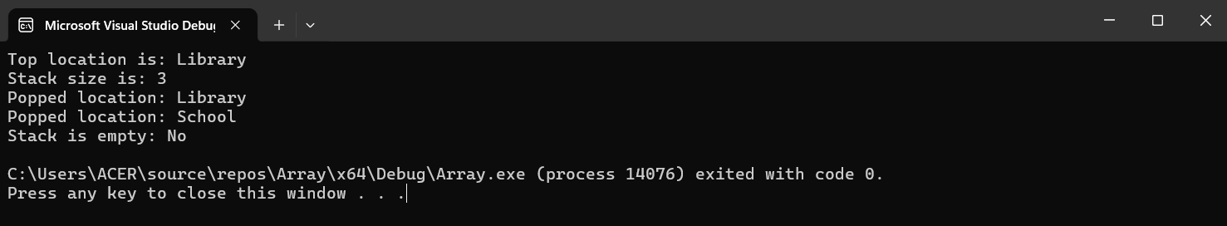

4. Queque

a) Discuss the concept of a queue. Differentiate between a circular queue and a priority queue.
A queue is a linear data structure that operates on the First In First Out (FIFO) principle, meaning the first data item stored will be the first accessed. Unlike some data structures, data entry and retrieval in a queue occur at different ends. A common example is a line of customers where the first customer in line is the first to be served. Key characteristics of a queue include its FIFO nature, the necessity to remove all preceding elements to remove the last element, and its structure as an ordered list of similar data types.
Circular Queue: A Circular Queue is a linear data structure where operations follow the FIFO (First In First Out) principle. Unlike a regular queue, the last position in a Circular Queue is connected back to the first position, forming a circle. This structure is also known as a 'Ring Buffer'.
Priority Queue: A Priority Queue is a specialized type of queue where each element is assigned a priority, and elements are served based on their priority level.
Circular Queue | Priority Queue
A Circular Queue is not linear but is a circular structure. | A Priority Queue is a specialized data structure where items are inserted and deleted based on their priority.
It is also known as a ring buffer. | It is also referred to as a simple queue.
Items can be inserted or deleted from a queue in constant time, O(1). | It can perform three operations: insertion, deletion, and display.
Both the front and rear pointers cycle back to the start of the array. | It does not permit elements to be in a sorted array.
It addresses the limitations of a linear queue. | It permits duplicate elements.
It demands less memory. | It demands more memory.
More efficient | Less efficient

b) Write a program for queue implementation.
#include <iostream>
#include <string>
using namespace std;

// Class to represent a Queue
class Queue {
private:
int front, rear, capacity;
string* queue;

public:
// Constructor to initialize the queue
Queue(int size) {
front = rear = -1;
capacity = size;
queue = new string[capacity];
}

// Destructor to free the allocated memory
~Queue() {
delete[] queue;
}

// Function to insert an element at the rear of the queue (enqueue)
void enqueue(const string& item) {
if ((rear + 1) % capacity == front) {
cout << "Queue is full. Cannot enqueue " << item << endl;
return;
}
if (front == -1) {
front = 0;
}
rear = (rear + 1) % capacity;
queue[rear] = item;
}

// Function to remove an element from the front of the queue (dequeue)
string dequeue() {
if (front == -1) {
cout << "Queue is empty. Cannot dequeue." << endl;
return "";
}
string item = queue[front];
if (front == rear) {
front = rear = -1;
} else {
front = (front + 1) % capacity;
}
return item;
}

// Function to get the front element of the queue
string getFront() {
if (front == -1) {
cout << "Queue is empty." << endl;
return "";
}
return queue[front];
}

// Function to get the rear element of the queue
string getRear() {
if (rear == -1) {
cout << "Queue is empty." << endl;
return "";
}
return queue[rear];
}

// Function to check if the queue is empty
bool isEmpty() {
return front == -1;
}

// Function to check if the queue is full
bool isFull() {
return (rear + 1) % capacity == front;
}

// Function to get the current size of the queue
int size() {
if (front == -1) return 0;
if (rear >= front) return rear - front + 1;
return capacity - front + rear + 1;
}
};

// Usage example
int main() {
Queue clothesQueue(5);

clothesQueue.enqueue("Shirt");
clothesQueue.enqueue("Pants");
clothesQueue.enqueue("Jacket");
clothesQueue.enqueue("Socks");

cout << "Front element is: " << clothesQueue.getFront() << endl; // Output: Shirt
cout << "Rear element is: " << clothesQueue.getRear() << endl; // Output: Socks

cout << "Queue size is: " << clothesQueue.size() << endl; // Output: 4

cout << "Dequeued: " << clothesQueue.dequeue() << endl; // Output: Shirt
cout << "Dequeued: " << clothesQueue.dequeue() << endl; // Output: Pants

cout << "Queue size after dequeuing two elements: " << clothesQueue.size() << endl; // Output: 2

cout << "Front element is now: " << clothesQueue.getFront() << endl; // Output: Jacket

return 0;
}
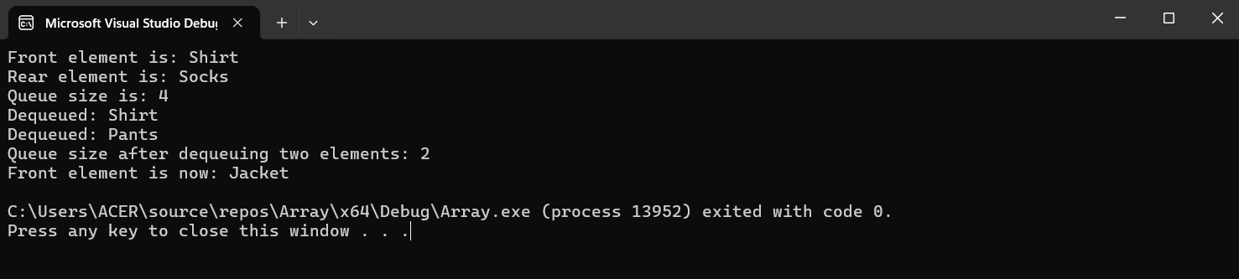
Output:

Non-Linear Data Structures (Non-Primitive)

1. Trees

a) Explain the hierarchical structure of trees. Differentiate between a binary tree and a binary search tree.
A tree is a hierarchical data structure. It is a group of nodes interconnected by edges and has a hierarchical relationship among the nodes. Each node has a value and pointers to its child nodes. The structure starts with a single node called the root. Each node (except the root) has one parent node and can have zero or more child nodes. Trees are used to represent hierarchical relationships, such as organizational structures, file systems, and decision processes.
Basic Terminologies In Tree Data Structure:
- Parent Node: A node that precedes another node is known as its parent node.
- Child Node: A node that is the immediate successor of another node is referred to as its child node.
- Root Node: The uppermost node in a tree, which does not have any parent node, is termed the root node. A non-empty tree must have one root node and exactly one path from the root to every other node in the tree.
- Leaf Node or External Node: Nodes that do not have any children are called leaf nodes.
- Ancestor of a Node: Any node that precedes another node on the path from the root to that node is called an ancestor of that node.
- Descendant: A node x is a descendant of another node y if and only if y is an ancestor of x.
- Sibling: Nodes that share the same parent are called siblings.
- Level of a Node: The number of edges on the path from the root node to that node. The root node is at level 0.
- Internal Node: A node that has at least one child is known as an internal node.
- Neighbor of a Node: The parent or child nodes of a node are called its neighbors.
- Subtree: Any node in the tree, along with all its descendants, forms a subtree.

Binary Tree: A binary tree is a tree where each element has at most two children. Because each element in a binary tree can have only two children, they are usually called the left and right children.
Binary Search Tree: A binary search tree is a hierarchical data structure in which each node has a maximum of two children, with values organized so that the left child's values are smaller and the right child's values are larger.
Binary Tree | Binary Search Tree
Nodes are inserted without any particular order. | Nodes are inserted based on their values, preserving the BST property.
No specific order; finding a node may require a complete traversal of the tree. | Efficient lookup leveraging the binary search property, which halves the search space with each step.
Insertion, deletion, and search operations have a time complexity of O(n). | Insertion, deletion, and search operations have a time complexity of O(h), where h is the height of the tree.
Space Complexity: O(n) because it solely depends on the number of nodes in the tree. | Space Complexity: O(n) because it solely depends on the number of nodes in the tree.
Utilized in numerous tree-related algorithms and data structures. | Perfect for applications that require efficient search, insertion, and deletion operations, such as in databases and dictionaries.

b) Write a program for binary tree implementation.
Program:
#include <iostream>
#include <queue>
#include <string>
using namespace std;

// Node class representing each node in the binary tree
class Node {
public:
string name; // Name of the family member
Node* left; // Pointer to the left child
Node* right; // Pointer to the right child

// Constructor to initialize a new node
Node(string name) {
this->name = name;
this->left = nullptr;
this->right = nullptr;
}
};

// BinaryTree class to manage the binary tree operations
class BinaryTree {
private:
Node* root; // Pointer to the root node of the tree

public:
// Constructor to initialize an empty binary tree
BinaryTree() {
root = nullptr;
}

// Function to insert a new node in the binary tree
void insert(string parentName, string name, bool isLeft) {
if (root == nullptr) {
// If the tree is empty, create the root node
root = new Node(name);
} else {
// Otherwise, find the parent node and insert the new node as a child
Node* parentNode = find(root, parentName);
if (parentNode != nullptr) {
Node* newNode = new Node(name);
if (isLeft) {
if (parentNode->left == nullptr) {
parentNode->left = newNode;
} else {
cout << parentName << " already has a left child." << endl;
}
} else {
if (parentNode->right == nullptr) {
parentNode->right = newNode;
} else {
cout << parentName << " already has a right child." << endl;
}
}
} else {
cout << "Parent node " << parentName << " not found." << endl;
}
}
}

// Function to find a node by name
Node* find(Node* node, string name) {
if (node == nullptr) {
return nullptr;
}
if (node->name == name) {
return node;
}
Node* leftNode = find(node->left, name);
if (leftNode != nullptr) {
return leftNode;
}
return find(node->right, name);
}

// Function to perform preorder traversal of the tree
void preorderTraversal(Node* node) {
if (node == nullptr) {
return;
}
cout << node->name << " ";
preorderTraversal(node->left);
preorderTraversal(node->right);
}

// Function to perform inorder traversal of the tree
void inorderTraversal(Node* node) {
if (node == nullptr) {
return;
}
inorderTraversal(node->left);
cout << node->name << " ";
inorderTraversal(node->right);
}

// Function to perform postorder traversal of the tree
void postorderTraversal(Node* node) {
if (node == nullptr) {
return;
}
postorderTraversal(node->left);
postorderTraversal(node->right);
cout << node->name << " ";
}

// Function to perform level order traversal of the tree
void levelOrderTraversal(Node* root) {
if (root == nullptr) return;

queue<Node*> q;
q.push(root);

while (!q.empty()) {
Node* node = q.front();
cout << node->name << " ";
q.pop();

if (node->left != nullptr)
q.push(node->left);

if (node->right != nullptr)
q.push(node->right);
}
}

// Function to delete a node in the binary tree
void deleteNode(Node*& root, string name) {
if (root == nullptr) return;

if (root->name == name) {
deleteSubtree(root);
root = nullptr;
return;
}

Node* parent = nullptr;
Node* node = findNodeWithParent(root, name, parent);

if (node != nullptr) {
deleteSubtree(node);
if (parent->left == node) {
parent->left = nullptr;
} else {
parent->right = nullptr;
}
} else {
cout << "Node " << name << " not found." << endl;
}
}

void deleteSubtree(Node* node) {
if (node == nullptr) return;
deleteSubtree(node->left);
deleteSubtree(node->right);
delete node;
}

Node* findNodeWithParent(Node* root, string name, Node*& parent) {
if (root == nullptr) return nullptr;
if (root->name == name) return root;

parent = root;
Node* foundNode = findNodeWithParent(root->left, name, parent);
if (foundNode == nullptr) {
foundNode = findNodeWithParent(root->right, name, parent);
}
if (foundNode == nullptr) {
parent = nullptr;
}
return foundNode;
}

// Wrapper functions to call the traversal methods from the root
void preorder() { preorderTraversal(root); cout << endl; }
void inorder() { inorderTraversal(root); cout << endl; }
void postorder() { postorderTraversal(root); cout << endl; }
void levelOrder() { levelOrderTraversal(root); cout << endl; }
void deleteNode(string name) { deleteNode(root, name); }
};

// Usage example
int main() {
BinaryTree familyTree;

// Insert family members
familyTree.insert("", "Donald Trump", true); // Root node
familyTree.insert("Donald Trump", "Ivana Trump", true); // Left child of Donald Trump
familyTree.insert("Donald Trump", "Melania Trump", false); // Right child of Donald Trump
familyTree.insert("Ivana Trump", "Donald Trump Jr.", true); // Left child of Ivana Trump
familyTree.insert("Ivana Trump", "Ivanka Trump", false); // Right child of Ivana Trump
familyTree.insert("Melania Trump", "Barron Trump", true); // Left child of Melania Trump

// Perform different traversals
cout << "Preorder Traversal: ";
familyTree.preorder();

cout << "Inorder Traversal: ";
familyTree.inorder();

cout << "Postorder Traversal: ";
familyTree.postorder();

cout << "Level Order Traversal: ";
familyTree.levelOrder();

// Delete a node
familyTree.deleteNode("Ivana Trump");

cout << "Inorder Traversal after deletion: ";
familyTree.inorder();

return 0;
}
Output:
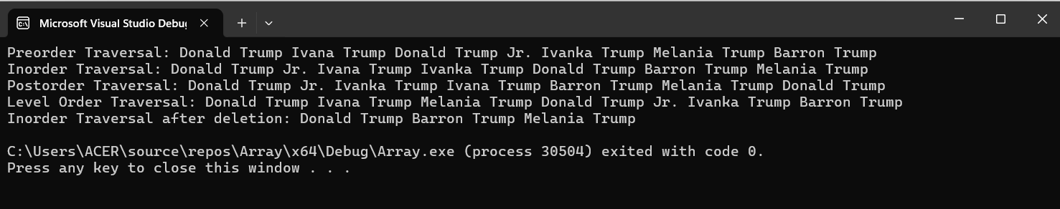

2. Graphs

a) Define a graph and discuss its various representations (adjacency matrix, adjacency list).
A graph is a non-linear data structure comprising vertices (or nodes) and edges that connect pairs of nodes. It includes a finite set of vertices and a set of edges that connect a pair of nodes, making it a powerful tool for solving complex programming problems. Key terminologies associated with graphs include path, degree, adjacent vertices, and connected components. Graph characteristics include the eccentricity of a vertex, which is the maximum distance from that vertex to all other vertices. The vertex with the minimum eccentricity is the graph's central point, and the smallest eccentricity value among all vertices is the graph's radius.
Graphs can be represented in several ways, with the most common representations being the adjacency matrix and the adjacency list.
Adjacency Matrix: An adjacency matrix represents a graph as a matrix consisting of boolean values (0s and 1s). It is a 2D array of size VxV where V is the number of vertices in the graph.
- Structure:
  - If there is an edge between vertex i and vertex j, then matrix[i][j] is set to 1 (or the weight of the edge if the graph is weighted).
  - If there is no edge, then matrix[i][j] is set to 0.
Adjacency List: An adjacency list represents a graph as an array of lists. The size of the array is equal to the number of vertices. The array's index represents a vertex in the graph, and each element in its linked list represents the vertices connected by an edge to that vertex. The entry at index 𝑖 of the array holds a linked list of vertices that are adjacent to vertex 𝑖.
- Structure:
  - adjList[0] will contain all the nodes that are connected to vertex 0.
  - adjList[1] will contain all the nodes that are connected to vertex 1, and so forth.

Operations | Adjacency Matrix | Adjacency List
Storage Space | This representation uses a VxV matrix, resulting in a worst-case space requirement of O(|V|^2). | In this approach, each vertex stores its neighbors. In the worst case for a connected graph, O(V) space is needed per vertex and O(E) space is required to store the neighbors for each vertex. Consequently, the overall space complexity is O(|V| + |E|).
Adding a vertex | To add a new vertex to a V×V matrix, the storage must be increased to (∣V∣+1) 2. This requires copying the entire matrix, resulting in a complexity of O(∣V∣ 2 ). | In an adjacency list, there are two pointers: one points to the front node and the other points to the rear node. This allows for the direct insertion of a vertex in O(1) time.
Adding an edge | To add an edge from i to j, set matrix[i][j] = 1, which takes O(1) time. | For adding an edge in an adjacency list, two pointers are used to point to the front and rear of the list. This allows an edge to be inserted in O(1) time.
Removing a vertex | To remove a vertex from a V×V matrix, the storage must be reduced from (∣V∣+1) 2 to ∣V∣ 2 . This requires copying the entire matrix, resulting in a complexity of O(∣V∣ 2 ). | To remove a vertex, we must first search for the vertex, which takes O(∣V∣) time in the worst case. Then, we need to traverse the edges, which in the worst case will take O(∣E∣) time. Therefore, the total time complexity is O(∣V∣+∣E∣).
Removing an edge | To remove an edge from i to j, set matrix[i][j] = 0, which takes O(1) time. | To remove an edge, traversing through the edges is necessary, and in the worst case, we may need to traverse all the edges. Thus, the time complexity is O(∣E∣).
Querying | To find for an existing edge in a matrix, the content of the matrix needs to be examined. Given two vertices i and j, checking matrix[i][j] takes O(1) time. | In an adjacency list, each vertex is associated with a list of adjacent vertices. To check for an edge, we need to examine the vertices adjacent to the given vertex. A vertex can have at most O(∣V∣) neighbors, and in the worst case, we would need to check each adjacent vertex. Therefore, the time complexity is O(∣V∣).

- Write a program for graph implementation.
Program:
#include <iostream>
#include <vector>
using namespace std;

class GraphAdjMatrix {
private:
vector<vector<int>> adjMatrix;
int numVertices;

public:
// Constructor to initialize the adjacency matrix
GraphAdjMatrix(int vertices) {
numVertices = vertices;
adjMatrix.resize(vertices, vector<int>(vertices, 0));
}

// Function to add an edge
void addEdge(int src, int dest) {
adjMatrix[src][dest] = 1;
adjMatrix[dest][src] = 1; // If the graph is undirected
}

// Function to display the adjacency matrix
void display() {
for (int i = 0; i < numVertices; i++) {
for (int j = 0; j < numVertices; j++) {
cout << adjMatrix[i][j] << " ";
}
cout << endl;
}
}
};

int main() {
GraphAdjMatrix graph(5);
graph.addEdge(0, 1);
graph.addEdge(0, 4);
graph.addEdge(1, 2);
graph.addEdge(1, 3);
graph.addEdge(1, 4);
graph.addEdge(2, 3);
graph.addEdge(3, 4);

cout << "Adjacency Matrix Representation:" << endl;
graph.display();

return 0;
}
Output:
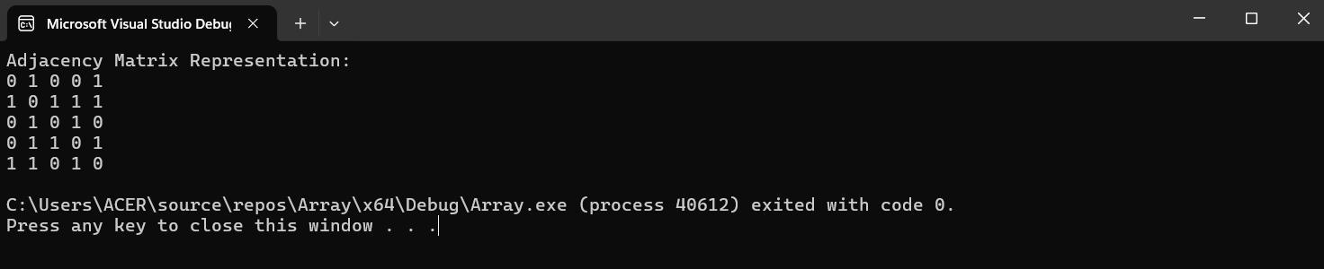

3. Hash Table

a) Describe the concept of a hash table. Discuss collision resolution techniques.
A hash table is a data structure designed for quick insertion, lookup, and removal of key-value pairs. It utilizes a hashing mechanism where a hash function converts each key into a unique index in an array. This index serves as the storage location for the corresponding value. Essentially, a hash table maps keys to their respective values efficiently.

Collisions occur when two or more keys map to the same index in an array. Several techniques for resolving collisions include chaining, open addressing, and double hashing.
There are two main types of collision resolution techniques in hash tables:
- Separate chaining (open hashing)
- Open addressing (closed hashing)
Separate chaining (open hashing): In separate chaining, “a linked list of objects that hash to each slot in the hash table is present". If multiple keys hash to the same slot, they are all stored in the linked list. This approach is straightforward and can handle numerous collisions. This method creates a linked list at the slot where a collision occurs, after that adding the new key to this list. The term "separate chaining" refers to how these linked lists of slots resemble chains. This technique is often used when the number of keys to add or remove is uncertain.
- Time complexity:
  - Worst-case complexity for searching: O(n)
  - Worst-case complexity for deletion: O(n)

- Advantages of separate chaining:
  - Easy to implement.
  - The hash table never becomes completely full, allowing for the addition of more elements.
  - Less sensitive to the specific hash function used.
- Disadvantages of Separate Chaining:
  - Poor cache performance.
  - Significant memory wastage.
  - Requires additional space for storing element links.

Open addressing (closed hashing): It is a collision-resolution technique that ensures all keys are stored within the hash table itself - not kept anywhere else. Thus, the size of the hash table is never equal to or less than the number of keys. It is also known as closed hashing.
Techniques used in open addressing include:
- Linear probing
- Quadratic probing
- Double hashing
Linear probing: This technique involves scanning sequentially for the next slot when a collision occurs, continuing this process until an empty slot is found. [Finding an empty slot can be quite time-consuming.] The worst-case time complexity for searching an element in linear probing is O. Although linear probing offers excellent cache performance, clustering is a concern. The primary advantage of this method is its simplicity in calculation.
Quadratic Probing: In this method, when a collision occurs, the probe searches for the i2-nd slot in the i-th iteration, continuing this process until an empty slot is found. Compared to linear probing, quadratic probing has poorer cache performance but reduces clustering issues.
Double Hashing: This technique uses another hashing algorithm. During the i-th iteration, the search is conducted at the location determined by (i×hash2(x)). While double hashing eliminates clustering problems, it has relatively poor cache performance and requires more time to determine two hash functions.

- Write a program for hash table implementation.
Program:
#include <iostream>
#include <list>
#include <vector>
using namespace std;

class HashTableSeparateChaining {
private:
int BUCKET;
vector<list<int>> table;

public:
HashTableSeparateChaining(int size) {
BUCKET = size;
table.resize(BUCKET);
}

void insert(int key) {
int index = key % BUCKET;
table[index].push_back(key);
}

void remove(int key) {
int index = key % BUCKET;
table[index].remove(key);
}

bool search(int key) {
int index = key % BUCKET;
for (int x : table[index]) {
if (x == key)
return true;
}
return false;
}

void display() {
for (int i = 0; i < BUCKET; i++) {
cout << i;
for (int x : table[i])
cout << " --> " << x;
cout << endl;
}
}
};

int main() {
HashTableSeparateChaining ht(7);

ht.insert(10);
ht.insert(20);
ht.insert(15);
ht.insert(7);
ht.insert(14);

cout << "Hash Table (Separate Chaining):" << endl;
ht.display();

cout << "Searching for 15: " << (ht.search(15) ? "Found" : "Not Found") << endl;
ht.remove(15);
cout << "Searching for 15 after removal: " << (ht.search(15) ? "Found" : "Not Found") << endl;

return 0;
}

Output:
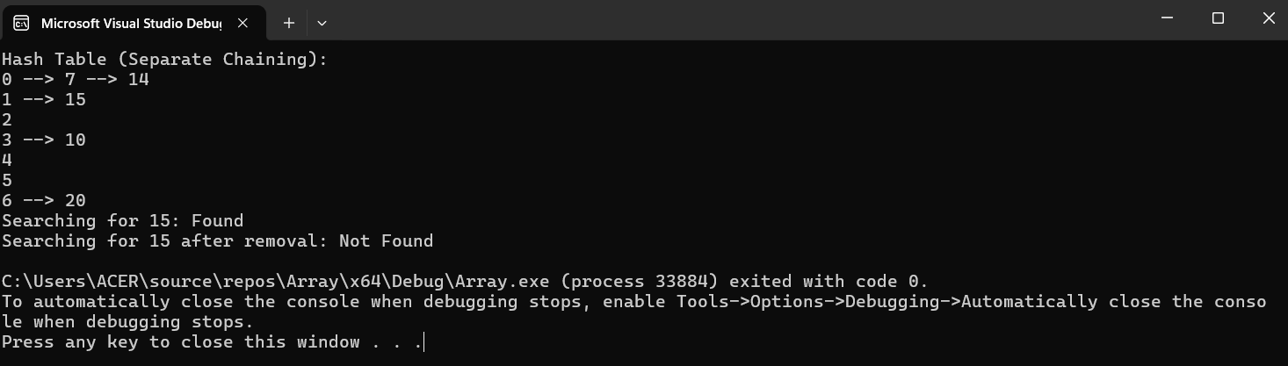

Overall

a) What is the difference between Non-Primitive (Linear data structure) and Non-Primitive (Non-linear data structure)
Linear Data Structure | Non-linear Data Structure
In a linear data structure, data elements are organized in a sequential order, with each element connected to its preceding and succeeding elements. | In a non-linear data structure, data elements are connected in a hierarchical manner.
In a linear data structure, there is only a single level involved. | In contrast, a non-linear data structure involves multiple levels.
Its implementation is easier compared to a non-linear data structure. | In contrast, implementing a non-linear data structure is more complex compared to a linear data structure.
In a linear data structure, data elements can be traversed in a single pass. | However, in a non-linear data structure, data elements cannot be traversed in just one pass
In a linear data structure, memory is not used efficiently. | In contrast, memory is utilized more efficiently in a non-linear data structure.
Examples of linear data structures include arrays, stacks, queues, and linked lists. | Examples of non-linear data structures include trees and graphs.
Linear data structures are primarily used in application software development. | Non-linear data structures are utilized in artificial intelligence and image processing.
Linear data structures are suitable for basic data storage and manipulation. | Non-linear data structures are ideal for representing complex relationships and data hierarchies, such as those found in social networks, file systems, or computer networks.
Performance in linear data structures is generally good for simple operations like adding or removing elements at the ends, but slower for tasks such as searching or removing elements in the middle. | Performance in non-linear data structures can vary based on the specific structure and operation, but can be optimized for certain tasks.

b) What is the difference between a Primitive and Non-Primitive data structure?
Data structures are categorized into two types: primitive and non-primitive:
- Primitive data structures include integers, floats, characters, and booleans.
- Non-primitive data structures can be divided into linear and nonlinear categories:
- Linear Data Structures: These structures organize data in a linear sequence (one dimension). The types included in this category are arrays, linked lists, stacks, and queues.
- Non-linear Data Structures: These structures don’t organize data items in a linear sequence (one – many, many – one, many – many dimensions) which allows for a more complex arrangement of data. For instance: trees, hash tables, tries and graphs.
Primitive | Non-Primitive
Primitive data types come predefined. | Non-primitive data types are defined by the programmer.
Primitive data types have specific values. | Non-primitive data types are capable of being NULL.
The size varies based on the data structure type. | The size is not constant.
It can begin with a lowercase letter. | It can begin with an uppercase letter.

c) Why we need to learn data structure (make a 2-page short report)
Computer scientist Nicklaus Wirth authored the programming textbook "Algorithms + Data Structures = Programs" (Prentice-Hall). This title encapsulates the essence of computer programming. Any program more complex than the basic "Hello, world!" typically requires a data structure to manage data and algorithms to transform data from input to output.
Underneath the surface, all SQL and Linux commands are based on algorithms and data structures? This fact is often overlooked, but it’s fundamental to how software functions.
There are two compelling reasons to learn Data Structures and Algorithms:
- To succeed in interviews and secure positions at product-based companies.
- To solve complex, real-world problems.

To succeed in interviews and secure positions at product-based companies.
For many programmers without formal computer science education, the array is the only data structure they know. While arrays are suitable for some tasks, they lack sophistication for many complex problems. Experienced programmers often find that once they identify the appropriate data structure, designing and implementing the necessary algorithms becomes easier.
One example of a data structure that facilitates efficient algorithms is the binary search tree (BST). A BST is designed to simplify finding the minimum and maximum values in a dataset, leading to more efficient algorithms than the best available search algorithms. Programmers unfamiliar with BSTs might use simpler, less efficient data structures.
A thorough study of data structures and algorithms teaches not only the most efficient options but also how to choose the most suitable ones for a specific problem.
Data structures and algorithms are crucial not only for software implementation but also in the hiring process. Many students and professionals wonder why companies focus on DSA in interviews instead of questions about specific languages, frameworks, or tools.
When you ask someone to make a decision, a skilled individual will explain, “I chose to do X because it’s better than A or B for these reasons. I could have chosen C, but I felt this was a better choice due to this.” In our daily lives, we rely on people who can complete tasks efficiently, using minimal resources. The same principle applies to these companies. They face complex problems on a large scale and need software developers who can make the best decisions to solve these issues.
Knowledge of data structures and algorithms, such as hashing, trees, graphs, and various other algorithms, is essential for solving problems efficiently. Interviewers want to see how candidates utilize these tools to address challenges. A programmer needs the right tools (algorithms and data structures) to ensure the software functions correctly. Therefore, interviewers look for candidates who can apply the appropriate tools to solve given problems. Understanding the characteristics of different data structures enables you to choose the most suitable one for a specific problem.
At Google, Microsoft, Facebook, and Amazon, coding is just the implementation phase, accounting for about 20-30% of the time allocated to a project. The majority of the time is spent designing optimal algorithms to save company resources (servers, computational power, etc.). This focus on algorithms in interviews is because these companies want individuals who can think innovatively to design algorithms that save significant costs. Platforms like YouTube, Facebook, Twitter, Instagram, and Google Maps have massive user bases. Handling this scale requires extensive optimization, which is why product-based companies seek candidates capable of optimizing their software to meet user demands.
Example: Suppose you work at Facebook and develop an optimal solution to a problem (such as sorting a list of users from India) with a time complexity of O(n log n) instead of O(n^2). Assuming n in this real-life scenario is 100 million (a reasonable assumption given Facebook's user base exceeds a billion), O(n log n) would be 800 million, while O(n^2) would be 10^7 billion. This improvement in efficiency, over 10^7 times, translates to substantial savings in terms of server costs and time.
Companies want to hire smart developers who can make the right decisions and save resources, time, and money. Before proposing a solution, such as using a hash table instead of a list, consider the scale and all potential scenarios. This thoughtful approach can either generate revenue for the company or prevent significant financial losses.

To solve complex, real-world problems.
Have you ever been angry for not finding your book or clothes in a messy room? Likely, yes. To keep everything in its place is spot-on, as it ensures you can easily find your stuff next time. This scenario highlights the importance of organizing data in real life.
Consider a library. If you need to find a book on Set Theory, you would go to the math section, then to the Set Theory subsection. If the books were scattered randomly, finding a specific one would be frustrating. Data structures work similarly for organizing information on computers. Computer scientists strive to find the best ways to organize data for efficient processing based on the input.

Many new programmers wonder where data structures and algorithms are used in daily life and how they help solve real-world problems.
- Facebook: Think about your friends, friends of friends, and mutual friends on Facebook. These connections can be represented using graphs. Take a moment to visualize it—you can use a graph to represent these relationships.
- Deck of Cards: If you need to organize a deck of cards, would you throw them randomly or stack them neatly one on top of another? Using a stack data structure allows you to arrange the cards properly.

These examples illustrate the importance of selecting the right data structure for real-world problems. Organizing data efficiently saves time and makes it easier to manipulate or use. We all seek the best approach to solve daily problems. Many problems in the world can take hours, days, or even years to solve using basic methods. We face numerous complex real-world problems without existing solutions. By observing these problems in-depth, you might find solutions no one has thought of before. Data structures and algorithms enable a deeper understanding of problems, enhancing our comprehension of the world.

d) What are Big-O complexities and why are they used in Computer Science (programming)?
Big O notation, it offers an abstract way to evaluate algorithm performance without relying on mathematical proofs.
We often focus not on the exact function C(n) that represents the time complexity of an algorithm in relation to the problem size n, but rather on its complexity class. This approach disregards constant overheads and minor constant factors, emphasizing the main growth trend of the complexity function with increasing problem size. This, in turn, provides insight into the algorithm's performance when dealing with large datasets. When an algorithm treats all steps as equally costly, its complexity class is typically determined by the number of loops and the frequency of their execution. This is because adding a fixed number of operations that do not vary with problem size has no substantial impact on the overall complexity for large-scale problems.
Big-O notation is the standard way to express that constant factors and other minor details are being overlooked. For instance, the procedure last(l) on a list l has a time complexity that scales linearly with the list's size n, thus we denote its time complexity as O(n). Similarly, linear search has a time complexity of O(n). On the other hand, binary search has a time complexity of O(log₂n).
Before formally defining complexity classes, it is beneficial to develop an intuitive understanding of their meanings. One effective approach is to select a representative function for each class we aim to consider. Remember, we are examining functions that map natural numbers (problem size) to non-negative real numbers R⁺, meaning the classes will align with common mathematical functions like powers and logarithms.
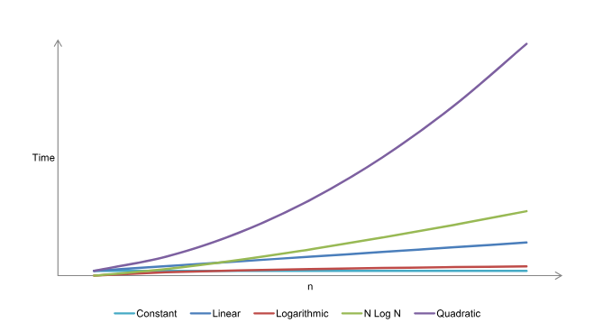

Figure 1: Algorithmic run time expansion
Common complexity classes and their representative functions:
O(1): Constant time complexity. The algorithm's runtime does not depend on the input size. For instance, inserting a new node at the end of a linked list while ensuring we always keep a reference to the last node.
O(log₂log₂n): Log log n time complexity.
O(log₂n): Logarithmic time complexity. The runtime grows logarithmically as the input size increases. Typically linked with algorithms that divide the problem into smaller parts with each invocation, such as searching in a binary search tree.
O(n): Linear time complexity. The runtime grows linearly with the input size.
O(nlog₂n): Linearithmic time complexity. The runtime grows in proportion to n log n. Commonly linked with algorithms that divide the problem into smaller segments with each invocation, and then integrate the outcomes of these smaller parts, like in quicksort.
O(n²): Quadratic time complexity. The runtime grows quadratically with the input size, exemplified by bubble sort. It is highly uncommon.
O(n³): Cubic time complexity. The runtime grows exponentially with the input size. It is incredibly rare.
O(2^{n}): Exponential time complexity.
O(n!): Factorial time complexity. The runtime grows factorially with the input size.

The table below shows the number of operations required for each algorithm to handle a problem of a specified size.
f(n) | n = 4 | n = 16 | n = 256 | n = 1024 | n = 1048576
1 | 1 | 1 | 1 | 1.00 x 10⁰ | 1.00 x 10⁰
log₂log₂n | 1 | 2 | 3 | 3.32 x 10⁰ | 4.32 x 10⁰
log₂n | 2 | 4 | 8 | 1.00 x 10¹ | 2.00 x 10¹
n | 4 | 16 | 256 | 1.02 x 10³ | 1.05 x 10⁶
nlog₂ n | 8 | 64 | 2.05 x 10³ | 1.02 x 10⁴ | 2.10 x 10⁷
n² | 16 | 256 | 6.55 x 10⁴ | 1.05 x 10⁶ | 1.10 x 10¹²
n³ | 64 | 4096 | 1.68 x 10⁷ | 1.07 x 10⁹ | 1.15 x 10¹⁸
2^{n} | 16 | 65536 | 1.16 x 10⁷⁷ | 1.80 × 10³⁰⁸ | 6.74 × 10³¹⁵⁶⁵²

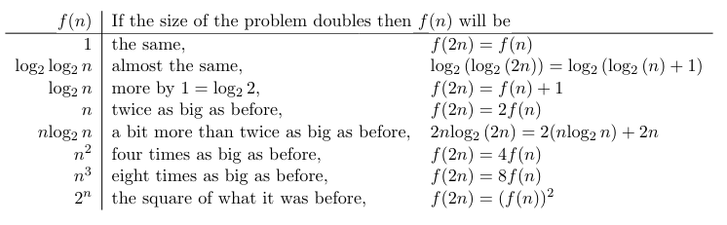

If the algorithm exhibits cubic or exponential run times, it's a strong indication that we should reevaluate its design. When prototyping algorithms, the primary goal may be to solve the problem without considering speed. However, it is crucial to consistently review and optimize your algorithm, particularly focusing on loops and recursive calls, to ensure efficient run times.
Big O notation offers a significant benefit by allowing us to ignore hardware details. For example, when comparing two sorting algorithms, one with a quadratic run time and the other with a logarithmic run time, the logarithmic algorithm will always be faster as the dataset size grows. This is because Big O notation emphasizes the growth rate in algorithm analysis, demonstrating that logarithmic growth is preferable to quadratic growth as the dataset size approaches infinity.
Furthermore, Big O notation is an effective communication tool among developers. Instead of only discussing the design of an algorithm, mentioning the asymptotic run time provides critical efficiency data, helping in selecting the most suitable algorithm for a given purpose.
In some situations, developers may have time constraints for each feature, where every feature has a maximum allowable time limit. Efficient algorithm design is vital, as surpassing the time limit for any feature can affect the product's success. Even without strict time limits, aiming for optimal solutions is essential in software development.

e) How do you select an appropriate data structure in your program?
Selecting the right data structure for a problem requires first analyzing the problem to understand the performance goals that must be met. Neglecting this analysis and using a familiar but unsuitable data structure often results in inefficient programs. Conversely, there's no benefit in using a complex data structure when a simpler one suffices to meet performance goals.
To choose an appropriate data structure, follow these three steps:
- Analyze the Problem: Identify the fundamental operations needed, such as inserting, deleting, or finding data items.
- Quantify Resource Constraints: Determine the resource requirements for each operation.
- Select the Best Data Structure: Choose the data structure that best meets these needs.
This approach emphasizes a data-centered design process. Start by considering the data and required operations, then decide on the data representation, and finally, implement that representation.
Key operations like searching, inserting, and deleting data records often drive the selection process. Consider these questions:
- Insertion: Are all data items inserted initially, or will insertions occur throughout? Static applications, where data doesn’t change after initial loading, often work well with simpler structures, while dynamic applications might need more complex ones.
- Deletion: Will data items be deleted? Deletion usually complicates implementation.
- Processing Order: Will data items be processed in a specific order, or is random access required? Random access typically needs more complex structures.
Each data structure has its costs and benefits. It's rare for one data structure is better than another for use in all situations. If one were clearly better in all situations, the inferior options would be obsolete. Most data structures and algorithms have specific scenarios where they excel, some of which may be unexpected.
A data structure's efficiency depends on its space requirements, the time to perform basic operations, and the programming effort involved. Every problem has constraints on space and time, and different operations will be used in varying proportions. A careful problem analysis is crucial to determine the best data structure for the task.

Bibliography
- GeeksforGeeks. (n.d.). Introduction to Data Structures. Retrieved from https://www.geeksforgeeks.org/introduction-to-data-structures/
- GeeksforGeeks. (n.d.). Common Operations on Various Data Structures. Retrieved from https://www.geeksforgeeks.org/common-operations-on-various-data-structures/
- GeeksforGeeks. (n.d.). What is Data Structure: Types, Classifications and Applications. Retrieved from https://www.geeksforgeeks.org/what-is-data-structure-types-classifications-and-applications/
- GeeksforGeeks. (n.d.). What is Array? Retrieved from https://www.geeksforgeeks.org/what-is-array/
- GeeksforGeeks. (n.d.). Difference between Singly linked list and Doubly linked list. Retrieved from https://www.geeksforgeeks.org/difference-between-singly-linked-list-and-doubly-linked-list/
- GeeksforGeeks. (n.d.). Difference between Circular Queue and Priority Queue. Retrieved from https://www.geeksforgeeks.org/difference-between-circular-queue-and-priority-queue/
- GeeksforGeeks. (n.d.). Introduction to Tree - Data Structure and Algorithm Tutorials. Retrieved from https://www.geeksforgeeks.org/introduction-to-tree-data-structure-and-algorithm-tutorials/
- GeeksforGeeks. (n.d.). Graph and Its Representations. Retrieved from https://www.geeksforgeeks.org/graph-and-its-representations/
- GeeksforGeeks. (n.d.). Comparison between Adjacency List and Adjacency Matrix Representation of Graph. Retrieved from https://www.geeksforgeeks.org/comparison-between-adjacency-list-and-adjacency-matrix-representation-of-graph/
- GeeksforGeeks. (n.d.). Hash Table Data Structure. Retrieved from https://www.geeksforgeeks.org/hash-table-data-structure/
- GeeksforGeeks. (n.d.). Collision Resolution Techniques. Retrieved from https://www.geeksforgeeks.org/collision-resolution-techniques/
- GeeksforGeeks. (n.d.). Difference between Linear and Non-linear Data Structures. Retrieved from https://www.geeksforgeeks.org/difference-between-linear-and-non-linear-data-structures/
- GeeksforGeeks. (n.d.). Primitive and Non-Primitive Data Types in JavaScript. Retrieved from https://www.geeksforgeeks.org/primitive-and-non-primitive-data-types-in-javascript/
- GeeksforGeeks. (n.d.). Why Data Structures and Algorithms are Important to Learn. Retrieved from https://www.geeksforgeeks.org/why-data-structures-and-algorithms-are-important-to-learn/
- OpenDSA. (n.d.). Introduction to Data Structures and Algorithms. Retrieved from https://opendsa-server.cs.vt.edu/ODSA/Books/Everything/html/IntroDSA.html
- Barnett, G., & Del Tongo, L. (2008). Data Structures and Algorithms: Annotated Reference with Examples.
- GeeksforGeeks. (n.d.). Introduction to Sorting Algorithm. Retrieved from https://www.geeksforgeeks.org/introduction-to-sorting-algorithm/
- YouTube. (n.d.). What is the Traveling Salesman Problem? Retrieved from https://www.youtube.com/watch?v=1pmBjIZ20pE&loop=0
- GeeksforGeeks. (n.d.). Binary Tree Data Structure. Retrieved from https://www.geeksforgeeks.org/binary-tree-data-structure/

